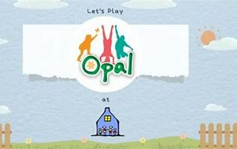
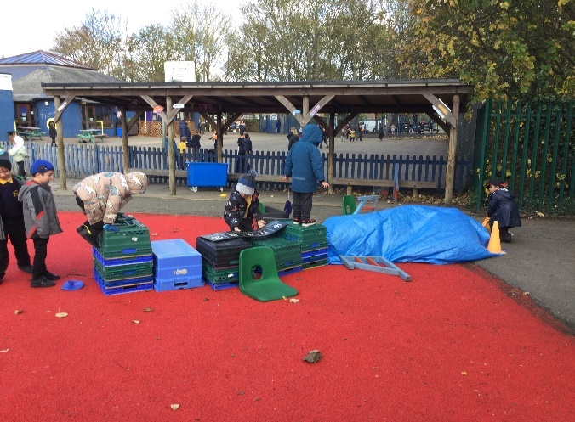 | 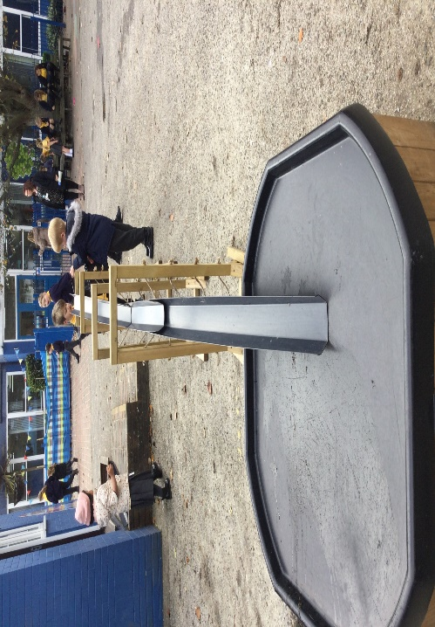 | 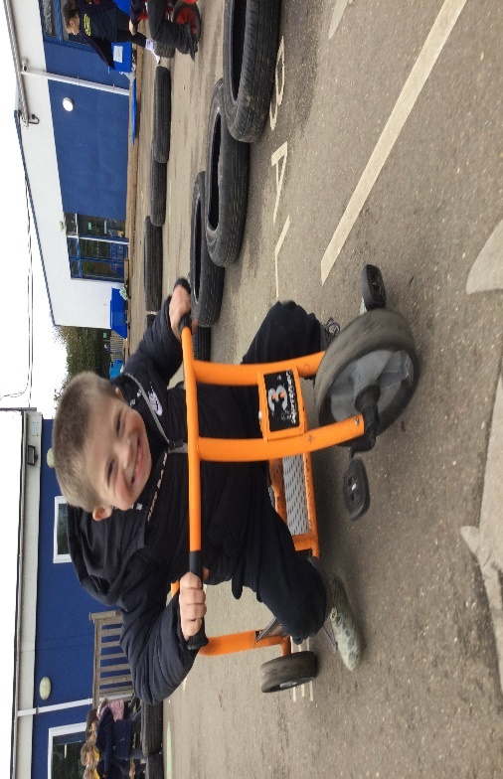
On the Astro, there were children working together to build a parkour area, using loose parts. | Here we have a long water run. The children worked together to pour the water. I wonder how many buckets of water they will use? | The children helped build the new bike track and now enjoy having racing each other. I wonder what else they could use tyres for.
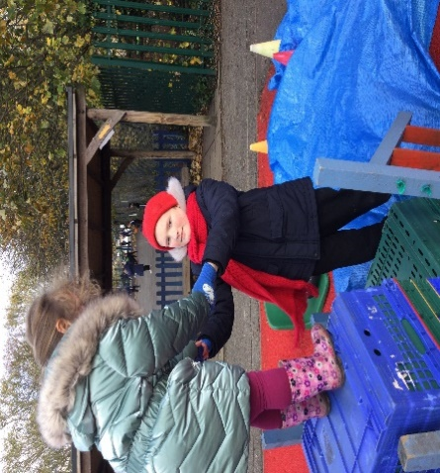 | 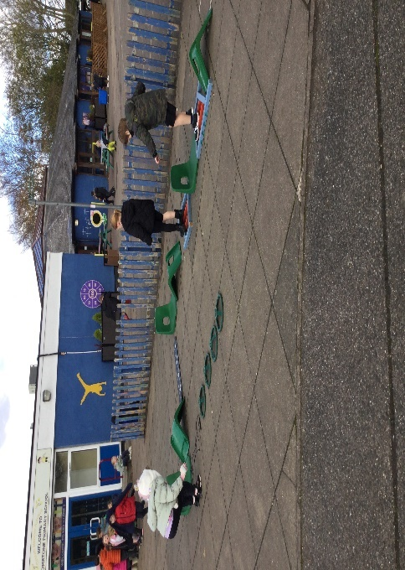 | 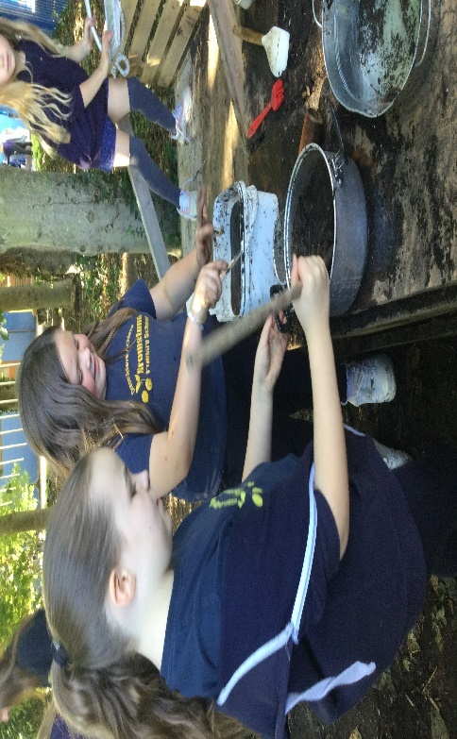
I like that when we play together, I can help other children too. | Being creative with chairs, mats, wheels and wood. As you can see the children balanced across the obstacle course | The pots and pans were very busy in Outdoor life with mud Pies, Chocolate brownies, cakes and mud soup. The children used tools to dig


