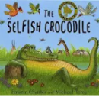
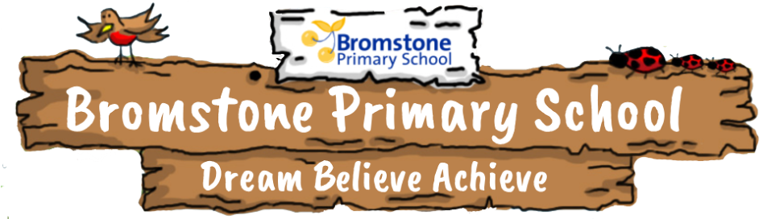

Home Learning Ideas
What happens when there is conflict?
KS1
- Watch or read the story of The Tortoise and the Hare. Talk to someone about what happens in the story
- Design a poster to help others when they have fallen out; what could they do to make up again?
- Make a friendship bracelet. 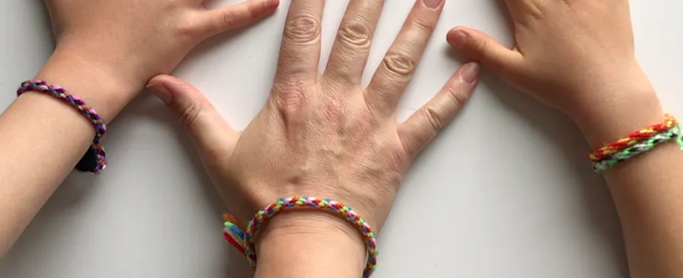
- Using your recycling can you design a junk model of home for the Three Little Pigs to protect them from the wolf?
- Watch or read the story the How to be a Lion by Rachel Bright. Write a poem inspired by the story.
- Be a gardener! Grow some sunflowers with your family, whose will grow the tallest!?
- Create a fact file about your favourite carnivore, what animals does it eat?
- Create a fact file about your favourite herbivore, how does it protect itself from carnivores? (E.g. Hedgehogs have spikes to stop foxes from eating them!)
- Read or watch the story 'The Selfish Crocodile'. Write a story and change the crocodile and mouse for different characters.
- Draw a picture on the theme of world peace.
- 

